Lab 3

Aaryan Pujara

102599490

4-bit register:

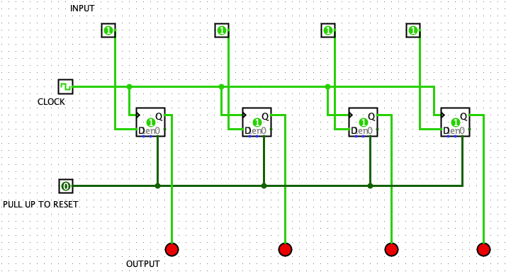

|  |  |  |
| --- | --- | --- |
| 0X | INPUT | OUTPUT |
| 0 | 0000 | 0000 |
| 1 | 0001 | 0001 |
| 2 | 0010 | 0010 |
| 3 | 0011 | 0011 |
| 5 | 0101 | 0101 |
| A | 1010 | 1010 |
| B | 1011 | 1011 |
| C | 1100 | 1100 |
| D | 1101 | 1101 |
| E | 1110 | 1110 |
| F | 1111 | 1111 |

1) Counter helps in counting the number of occurrences in a circuit it can also store and increment the number of occurrences in the circuit.

2) The ripple flip flop is called by its name because only the first flip flop is clocked by a clock all the rest of them are clocked by the output of the previous ones. A ripple is happened when clock pulse travels through the flip flops.

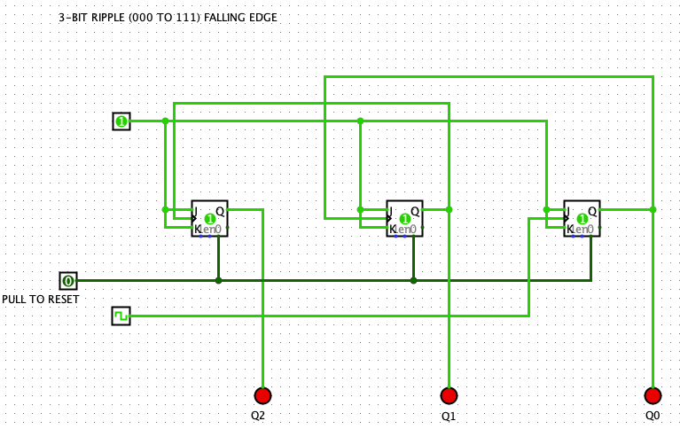

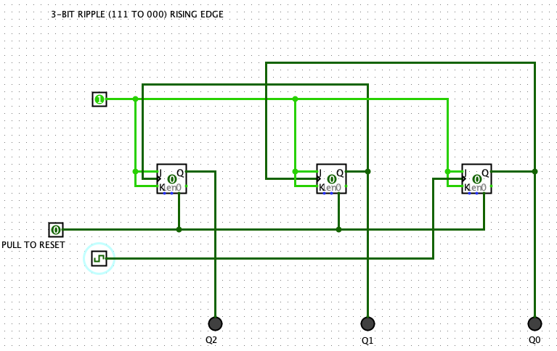

3-BIT COUNTER WITH COMMON CLOCK

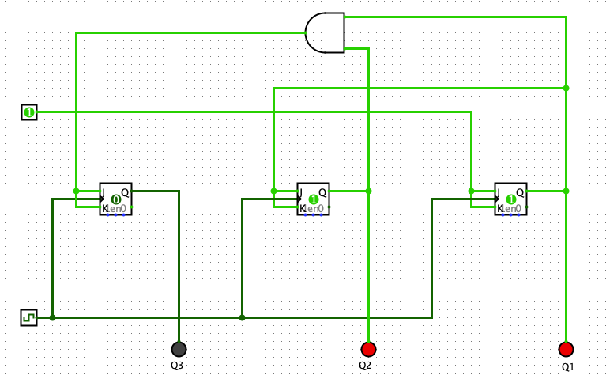

MOD 6

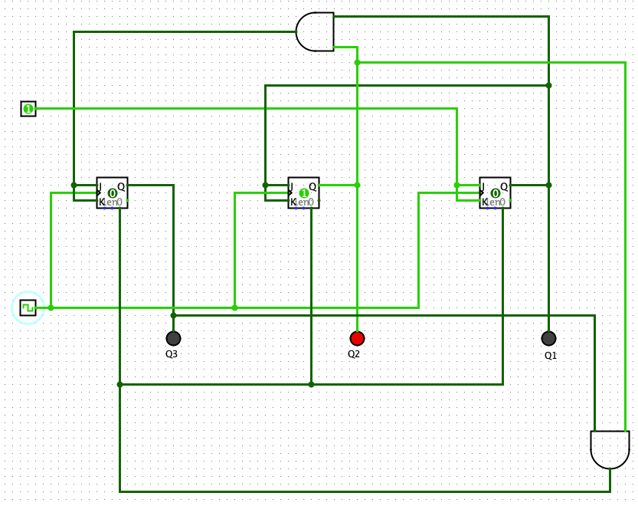

MOD 6 BUFFER w hex

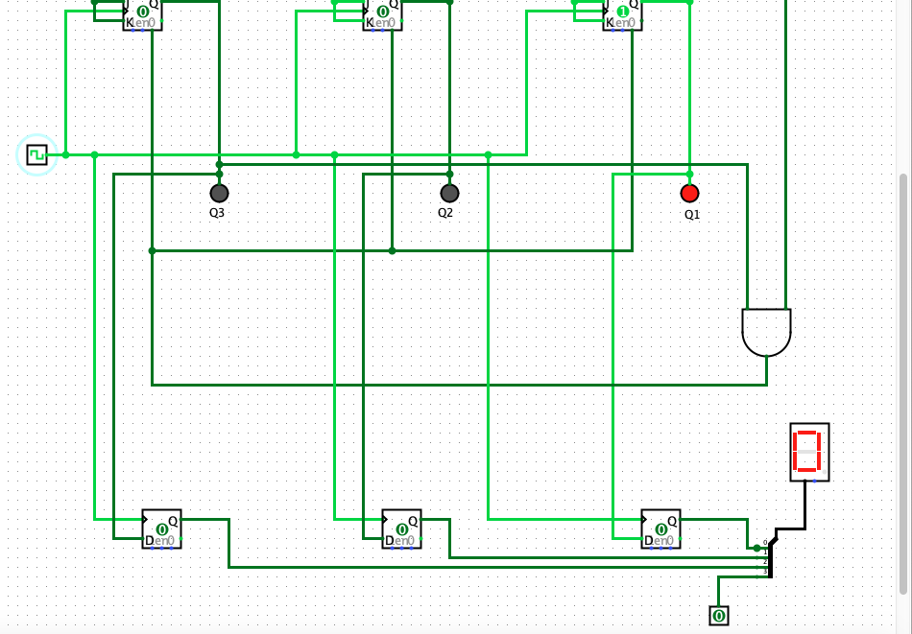

3) not handling such things can lead to illegal state which can potentially ruin the functioning of the circuit.